A evaluation of interstitial lung disease -: Survival guide for fibrotic lung disease
(Dr. Mirinda)

Reflections and description:

4 main categories of diagnosis-:
- UIP- usual interstitial pneumonia (Crohn’s disease of lung !)
- NSIP- : Non-specific interstitial pneumonia (Ulcerative colitis of lung !)
- FHP-: Fibrotic hypersensitivity pneumonia (fibrosis with airway involvement leading to air trapping)
- Non-specific scaring due to local causes such as osteophytes / radiation etc
- ILA- fibrotic patterns in asymptomatic patients.

Three main disease :
- UIP
- ILD
- FHP

UIP: Peripheral and basal distribution of reticulation -: Three main checklist points for diagnosis-:
- Reticulation
- Traction bronchiectasis
- May or may not be honeycombing (usually 3-4 mm and tend to be symmetrical in size). The cyst in honeycombing should share wall unlike other cysts. The walls tend to be thicker on honeycombing unlike parseptal emphysema.
Fibrosis should be filling the costophrenic angle (sign of basal disease- money shot finding !.
Fine reticulation means- band < 4 mm apart.
The disease tend to be patchy - there will be small patches of skip areas (correlated with histology- as temporal heterogeneity).
Diagnostic criterion and diagnostic categories of UIP-:
- Typical (very high confidence –MDT will decide- no biopsy needed)l- UIP pattern with all features.
- Probable (80 % confidence-most likely MDT do not offer biopsy)- everything that is typical but with NO honeycombing (critical to use these terms as clinical team will decide whether or not to biopsy and also has prognostic implication).
- Do not use the term idiopathic pulmonary fibrosis- because it is clinical job to check if the fibrosis is indeed idiopathic or has a definable aetiology.
- Indeterminate pattern -:
  - inconspicuous
  - non UIP features.
- Non – IPF-: when we see
  - upper and mid zone
  - PBV
  - subpleural sparing.
  - Chronic GG
  - air trapping
  - nodules
  - consolidation and cysts.

Fibrotic hypersensitivity pneumonitis (HP)-: Three main checklist points for making diagnosis are -:
- Air trapping / Ground glass nodules.
- Fibrosis- there is significant contribution from peribronchovascular component of fibrosis and lesser degree of peripheral fibrosis (unlike UIP). This is also known as axial distribution of the fibrosis.
- Three densities sign- very specific sign. This means- three densities will be there -:
  - Lucent area of lung due to air trapping.
  - Normal grey lung
  - Dense whiter lung with GGO

HP is thought to be upper zone disease- but in reality, this is NOT true.
Not all honeycombing are UIP- it can be HP ! The HP honeycombing is central/axial/ peribronchhovascular in FHP.
As HP progresses, the lung burns out and air trapping and three density appearance becomes less and less apparent.

NSIP-: Non specific interstitial pneumonia-:
Most important features is that there is a thin rim of lung between the fibrosis and the pleura.
Secondly, the disease do not have skip lesion (so you can call it Ulcerative colitis of lung !).
It is homogenous distribution- correlated with histopathological temporal homogenousity.

Component of GGO that is clearly away from the areas of fibrosis will justify using immunosuppression (do not look for GGO in the area of fibrosis as this kind of GGO can be spuriously apparent due to partial volume effect).
Beware of dependent GGO – can be due to micro-atelectasis due to patient lying on bed for long time- very common. That’s why we do prone imaging.
General points

- Reflux predispose to fibrosis.
- Emphysema causes masking of the diagnosis- the spirometry becomes become tricky as emphysema offsets the effect of fibrotic lung disease. So DLO is important.
- Fibrotic lung disease leads to increased risk of cancer.

Reporting fibrotic lung disease-:
In Symptomatic patients
HRCT Lung-:
Observations-:
Coronal/Axial distribution
Reticulation/traction Bx/ Honeycombing (subpleural sparing/air trapping)
Rest of the lung (emphysema/ cancer)
Size of pulmonary artery/right heart
Hiatus hernia

Conclusion -:
[extent] {mild/moderate/extensive extent} fibrotic lung disease [radiological pattern and category] {Typical UIP/Probable UIP/ indeterminate UIP/NSIP/FHP} pattern.
[progression over years] {no progression / mild progression/ moderate progression/ marked progression}
.
In asymptomatic patients-: (usually small volume disease- also known as ILA- Interstitial Lung Abnormalities with no definite diagnosis)
- Report in conclusion only if > 5 % lung volume involved. If less than that, then burry the findings in body of report.
- This is significant diagnosis -:
  - All typical / probable UIP will progress in 5 years.
  - Greatly increase in risk of ARDS in sepsis (75% v/s15%)
So if > 5 % involvement then refer to respiratory.

Summary-: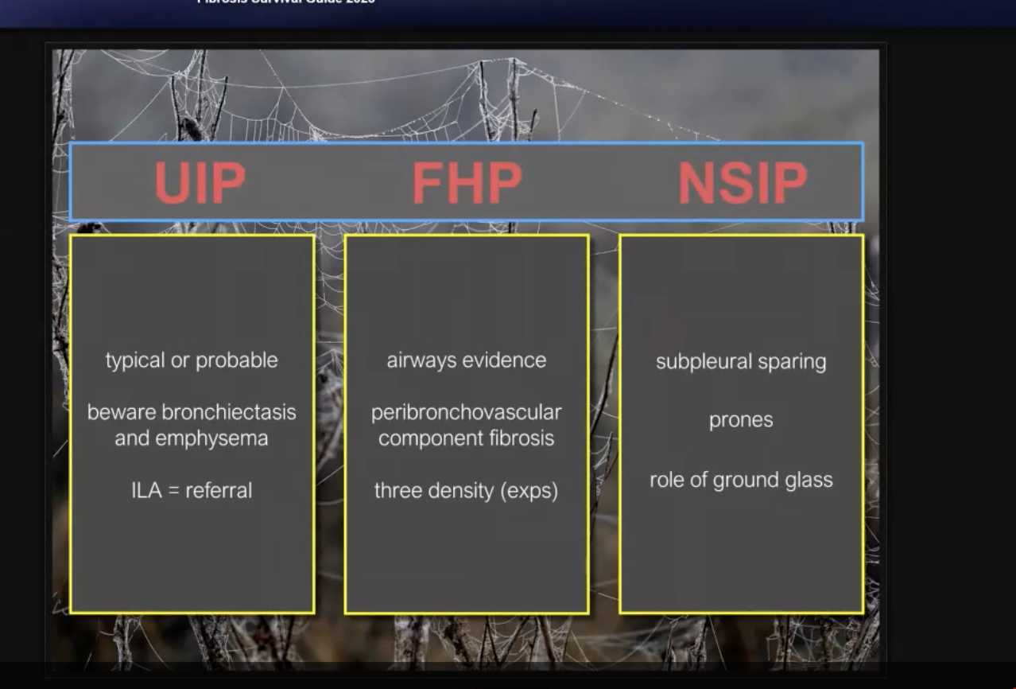

CT Protocol of fibrotic lung disease-: first do inspiratory supine scan. If on initial review there is abnormality is posterior lung, then turn the patient prone. If there is possibility of HP (air trapping) then include expiratory scan.

Some additional points to remember-:

- ILA is term applied only in asymptomatic settings irrespective of extent of involvement – though it is very unlikely that patient with > 5 % abnormality will be symptomatic, you probably don’t know it and they are in fact symptomatic.
- To assess the extent of the lung involvement- look at coronal images.
- Association is between hiatus hernia and reflux lead to higher likelihood of lung fibrosis and treating the hernia and reflux is helpful in managing fibrosis.
- Also, oesophageal abnormality will be seen Scleroderma- which is one of the aetiology of NSIP.
- Anti-fibrotic drugs do not lead to any improvement in lung function- Similarly they do not lead to any imaging improvement.
- This is because anti fibrotic drugs only help in stabilisation of the disease but not help in reducing it.
- Anti-fibrotic drugs are only helpful in UIP. But recently there are studies that anti fibrotic may be also be used in UIP and HSP.

